SDLC (Software Development Life Cycle) is a structured process used to plan, design, build, test, deploy, and maintain software systems.
Common SDLC Phases
- Requirements Gathering & Analysis
  - Identify business needs and user requirements.
  - Create requirement specifications.
- Planning
  - Define scope, resources, budget, timeline, and risks.
- System Design
  - Create architecture, database design, UI/UX designs, and technical specifications.
- Development (Coding)
  - Developers implement the software according to the design.
- Testing
  - Verify functionality, performance, security, and quality.
  - Fix defects and bugs.
- Deployment
  - Release the software to production or end users.
- Maintenance
  - Monitor, update, enhance, and fix issues after release.
Popular SDLC Models
- Waterfall – Sequential phases.
- Agile – Iterative and incremental development.
- Scrum – Agile framework using sprints.
- Spiral – Risk-driven iterative approach.
- V-Model – Testing aligned with development stages.
- DevOps – Integrates development and operations for continuous delivery.
Simple Flow
Requirements → Planning → Design → Development → Testing → Deployment → Maintenance
SRS Document (Software Requirements Specification)
An SRS (Software Requirements Specification) document describes what a software system should do, including its functional and non-functional requirements. It acts as an agreement between stakeholders, customers, developers, and testers.
Purpose of an SRS Document
- Defines project requirements clearly.
- Reduces misunderstandings between stakeholders and developers.
- Serves as a reference throughout the SDLC.
- Helps in testing and validation.
Typical Structure of an SRS Document
1. Introduction
- Purpose of the project
- Scope of the system
- Definitions and abbreviations
- References
2. Overall Description
- Product perspective
- Product functions
- User characteristics
- Assumptions and constraints
3. Functional Requirements
Describes what the system should do.
Example:
- User Registration
- User Login
- Password Reset
- Product Search
4. Non-Functional Requirements
Describes how the system should perform.
Examples:
- Performance
- Security
- Reliability
- Scalability
- Usability
5. System Requirements
- Hardware requirements
- Software requirements
- Network requirements
6. Use Cases
Describes interactions between users and the system.
Example:
- Login Use Case
- Order Placement Use Case
7. Appendices
- Glossary
- Supporting documents
- Diagrams
Simple Example
Project: Online Shopping System
Functional Requirement:
- Users can register and log in.
- Users can search products.
- Users can add products to the cart.
- Users can place orders.
Non-Functional Requirement:
- Response time should be less than 2 seconds.
- System should be available 99.9% of the time.
- User passwords must be encrypted.
SRS in SDLC
The SRS document is created during the Requirements Analysis phase and is used by developers, testers, project managers, and clients throughout the project lifecycle.
HLD (High-Level Design)
HLD (High-Level Design) is a document that describes the overall architecture and design of a software system. It is created after the SRS document and before detailed coding begins.
Purpose of HLD
- Provides a blueprint of the system architecture.
- Helps developers understand how different modules interact.
- Identifies technologies, databases, and system components.
- Serves as a guide for detailed design and development.
Contents of an HLD Document
- System Architecture
  - Overall structure of the application.
  - Client-server architecture, microservices, etc.
- Modules and Components
  - Major modules of the system.
  - Responsibilities of each module.
- Database Design
  - Database type and major tables.
  - Relationships between entities.
- Technology Stack
  - Programming languages
  - Frameworks
  - Databases
  - Cloud platforms
- Integration Details
  - APIs
  - Third-party services
  - External systems
- Security Design
  - Authentication
  - Authorization
  - Data protection
Example: Online Shopping System HLD
- Frontend: React
- Backend: Java Spring Boot
- Database: MySQL
- Modules:
  - User Management
  - Product Catalog
  - Shopping Cart
  - Order Management
  - Payment Gateway
- Cloud: AWS
HLD vs SRS
SRS | HLD
Defines what the system should do | Defines how the system will be built
Focuses on requirements | Focuses on architecture and design
Created by Business Analysts | Created by Solution Architects/Tech Leads
Input for design phase | Input for development phase
SDLC Flow
Requirements → SRS → HLD → LLD → Development → Testing → Deployment
LLD (Low-Level Design)
LLD (Low-Level Design) is a detailed design document that explains how each module and component will be implemented. It is created after the HLD phase and before coding starts.
Purpose of LLD
- Provides detailed implementation guidance for developers.
- Defines classes, methods, database schemas, APIs, and logic.
- Reduces ambiguity during development.
- Makes coding and testing easier.
Contents of an LLD Document
- Class Diagrams
  - Classes, attributes, methods, and relationships.
- Database Design
  - Table structures
  - Columns, data types, constraints
  - Primary and foreign keys
- API Design
  - Endpoints
  - Request/response formats
  - Error codes
- Sequence Diagrams
  - Interaction between components step-by-step.
- Business Logic
  - Detailed workflows and algorithms.
- Validation Rules
  - Input validations
  - Error handling
Example: Login Module LLD
Database Table
Users
- user_id (PK)
- username
- email
- password_hash
API
POST /api/login
Request
{
"email": "user@example.com",
"password": "password123"
}
Response
{
"token": "jwt_token"
}
Logic
- Validate email and password.
- Check user exists.
- Verify password hash.
- Generate JWT token.
- Return token.
HLD vs LLD
HLD | LLD
High-level architecture | Detailed implementation
System modules | Classes, methods, APIs
Created by Architects/Tech Leads | Created by Developers/Tech Leads
Describes overall design | Describes component-level design
SDLC Design Flow
Requirements → SRS → HLD → LLD → Development → Testing → Deployment
FULL SDLC NOTES
https://www.geeksforgeeks.org/software-engineering/software-development-life-cycle-sdlc/
SDLC Models
SDLC models define how software development phases are organized and executed.
1. Waterfall Model
- Sequential approach.
- Each phase must be completed before the next begins.
- Best for projects with clear and fixed requirements.
Flow:
Requirements → Design → Development → Testing → Deployment → Maintenance
Advantages:
- Simple and easy to manage.
- Well-documented.
Disadvantages:
- Difficult to accommodate changes.
- Testing happens late.

2. Agile Model
- Iterative and incremental approach.
- Development is divided into small cycles called sprints.
Advantages:
- Flexible to changing requirements.
- Faster delivery of features.
- Continuous customer feedback.
Disadvantages:
- Requires active customer involvement.
- Less predictable cost and timeline.

3. Scrum Model
- A framework within Agile.
- Work is completed in short sprints (usually 2–4 weeks).
Roles:
- Product Owner
- Scrum Master
- Development Team
Advantages:
- High collaboration.
- Frequent releases.

4. Spiral Model
- Combines iterative development with risk analysis.
- Suitable for large and high-risk projects.
Phases:
Planning → Risk Analysis → Engineering → Evaluation
Advantages:
- Better risk management.
- Flexible and scalable.
Disadvantages:
- Expensive.
- Complex to manage.

5. V-Model (Verification and Validation Model)
- Extension of the Waterfall model.
- Testing is planned alongside each development phase.
Advantages:
- Early testing.
- High-quality deliverables.
Disadvantages:
- Difficult to handle changing requirements.

6. Incremental Model
- Software is developed and delivered in smaller increments.
- Each increment adds new functionality.
Advantages:
- Early delivery of working software.
- Easier testing and debugging.

7. DevOps Model
- Integrates development and operations teams.
- Focuses on automation, continuous integration, and continuous delivery.
Practices:
- Continuous Integration (CI)
- Continuous Delivery (CD)
- Infrastructure as Code (IaC)
- Monitoring
Advantages:
- Faster releases.
- Improved collaboration.
- Better reliability.

Comparison Table
Model | Best For | Flexibility
Waterfall | Fixed requirements | Low
Agile | Dynamic requirements | High
Scrum | Agile teams | High
Spiral | High-risk projects | High
V-Model | Quality-focused projects | Low
Incremental | Gradual delivery | Medium
DevOps | Continuous delivery | Very High
Agile Model
What is Agile?
Agile is a software development methodology that focuses on continuous delivery, customer collaboration, flexibility, and iterative development.
Instead of building the entire software at once, Agile divides the project into small parts called iterations or sprints. Each sprint delivers a working piece of software.
Agile Principle
"Build software in small increments, get feedback quickly, and continuously improve."

Why Agile?
Traditional models like Waterfall have difficulties handling changing requirements.
Agile solves this by:
- Adapting to changes quickly.
- Delivering software faster.
- Involving customers throughout the project.
- Improving product quality through continuous testing.

Agile Lifecycle
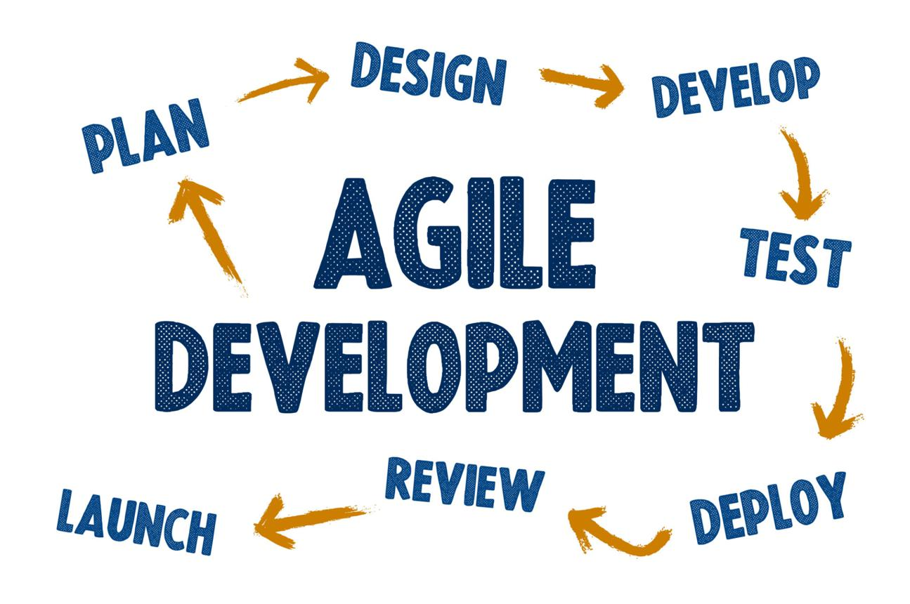
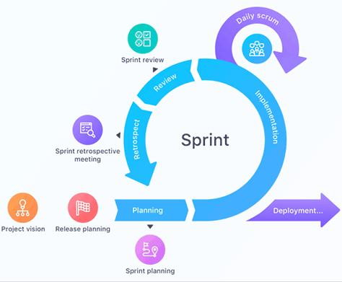
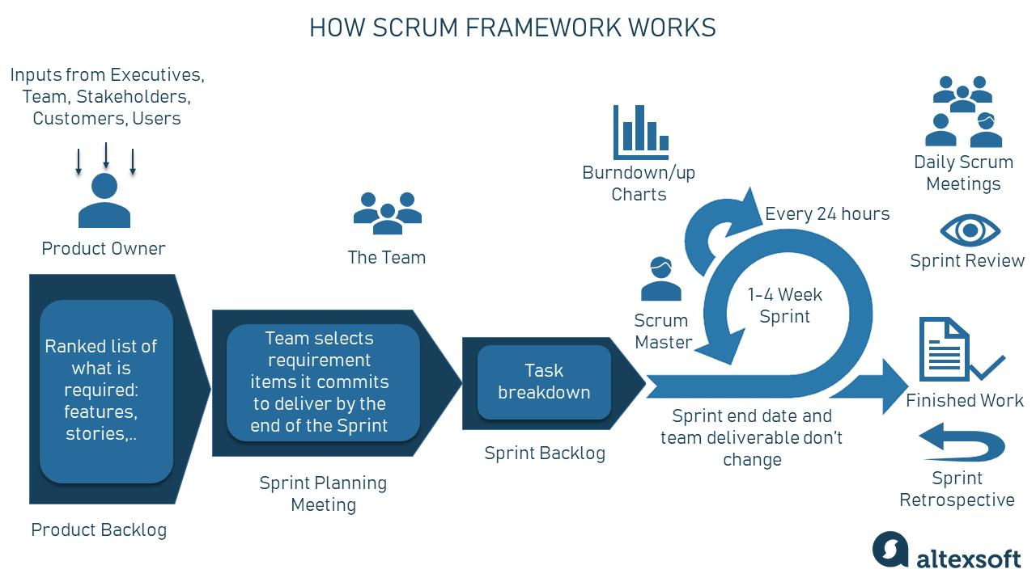
6
1. Requirements Gathering
- Collect business requirements.
- Create a list called the Product Backlog.
2. Sprint Planning
- Select features from the backlog.
- Define sprint goals.
- Usually planned for 2–4 weeks.
3. Design & Development
- Developers build the selected features.
- Team collaborates continuously.
4. Testing
- Testing happens during development.
- Bugs are fixed immediately.
5. Review
- Demonstrate completed work to stakeholders.
- Collect feedback.
6. Retrospective
- Team discusses:
  - What went well?
  - What can be improved?
- Apply improvements in the next sprint.
7. Release
- Deploy the completed features.
- Continue with the next sprint.

Agile Workflow
Product Backlog
↓
Sprint Planning
↓
Development
↓
Testing
↓
Sprint Review
↓
Sprint Retrospective
↓
Next Sprint
Waterfall Model
The Waterfall Model is a traditional SDLC model where development progresses through a series of sequential phases. Each phase must be completed before moving to the next phase.
It is called "Waterfall" because the process flows downward like a waterfall.
Waterfall Phases
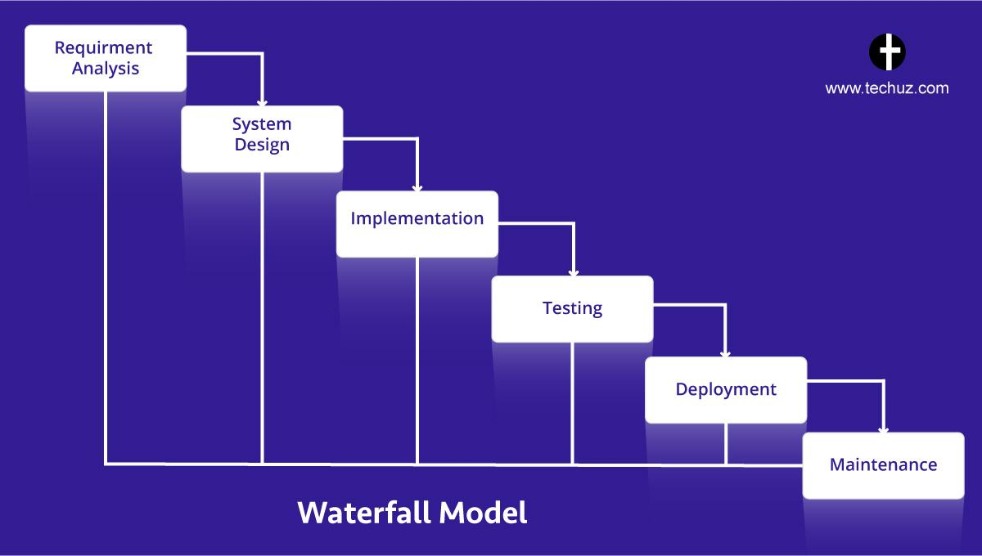
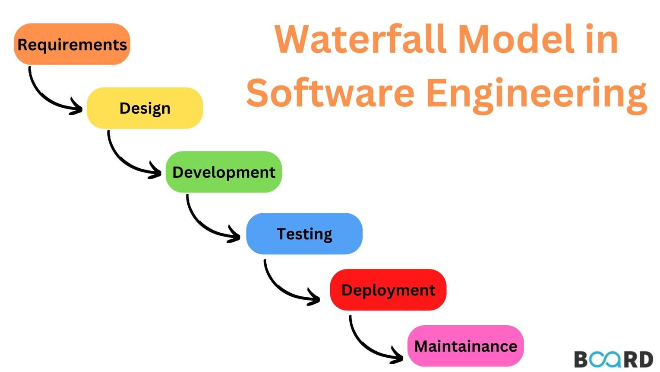
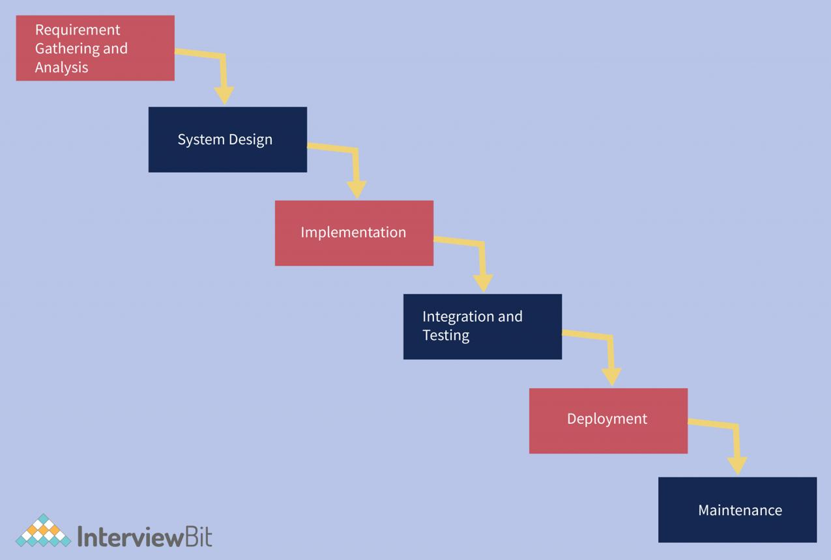
5
1. Requirements Analysis
- Gather and document all requirements.
- Create the SRS (Software Requirements Specification) document.
2. System Design
- Create HLD (High-Level Design).
- Create LLD (Low-Level Design).
- Define architecture, database, and technologies.
3. Development (Coding)
- Developers write the code based on design documents.
4. Testing
- Test the complete application.
- Identify and fix bugs.
5. Deployment
- Release the software to users.
6. Maintenance
- Fix issues and provide updates after deployment.
Waterfall Flow
Requirements
↓
Design
↓
Development
↓
Testing
↓
Deployment
↓
Maintenance

Advantages of Waterfall
✅ Simple and easy to understand
✅ Clear documentation
✅ Easy project management
✅ Suitable for small projects with fixed requirements
✅ Well-defined milestones

Disadvantages of Waterfall
❌ Difficult to change requirements once development starts
❌ Testing happens late in the cycle
❌ Customer feedback comes very late
❌ Higher risk if requirements are misunderstood
❌ Not suitable for dynamic projects
Scrum in Agile
Scrum is the most popular Agile framework used to manage and develop software projects. It helps teams deliver working software in short, time-boxed iterations called Sprints.
Agile vs Scrum
- Agile = Methodology/Principles
- Scrum = Framework used to implement Agile
Think of it this way:
Agile is the philosophy, Scrum is one of the ways to practice it.

Scrum Process
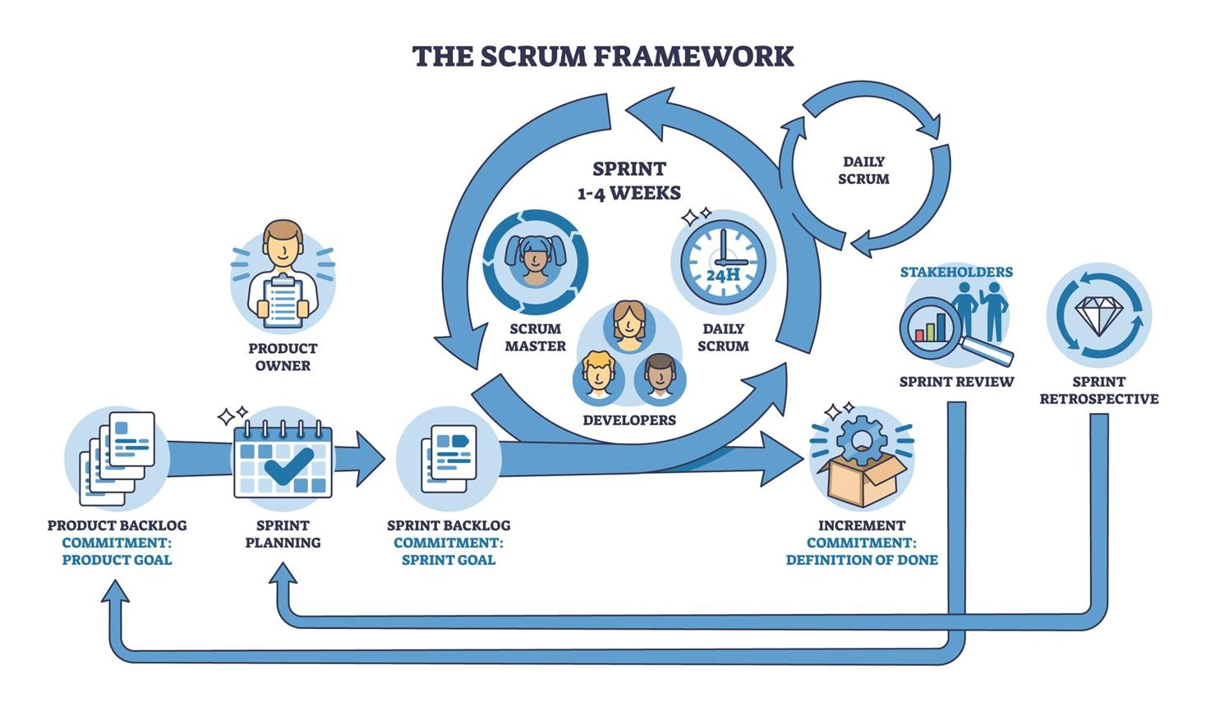
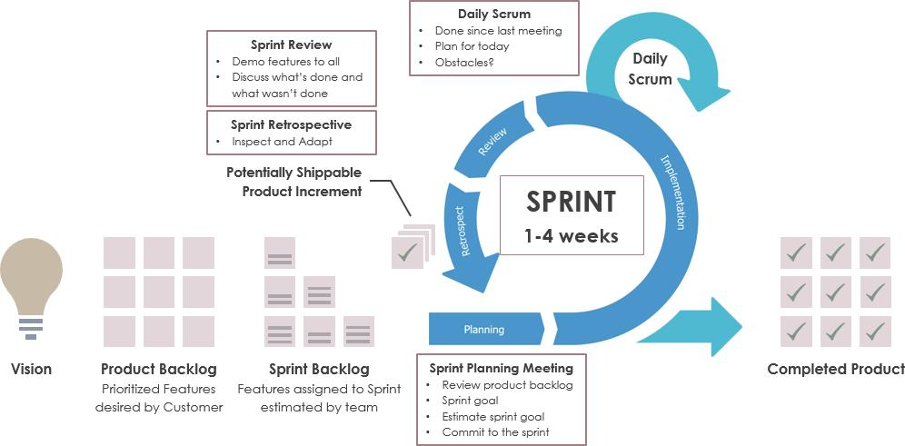
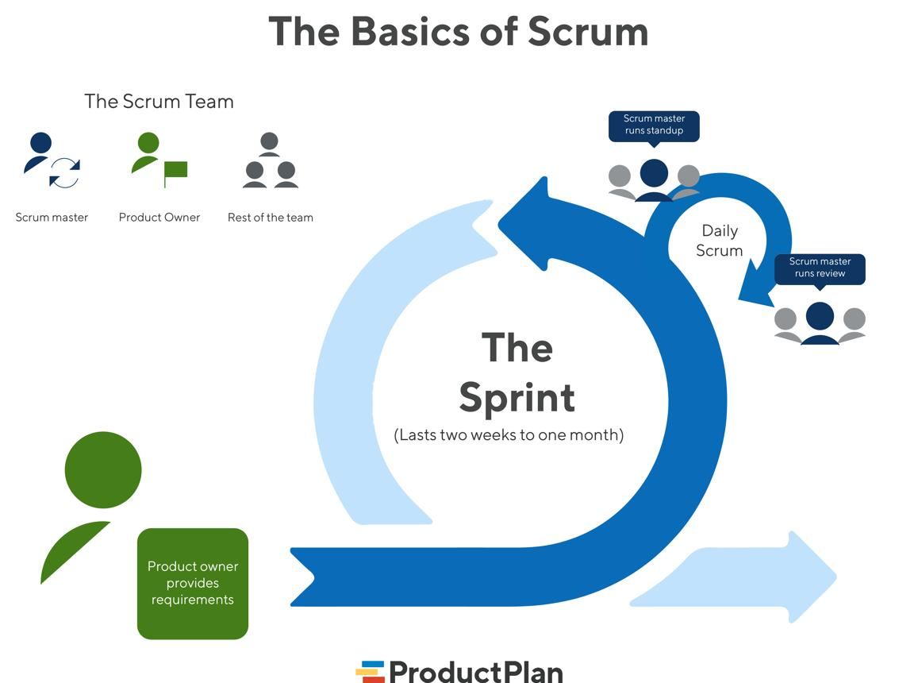
6
Product Backlog
↓
Sprint Planning
↓
Sprint Backlog
↓
Sprint (2–4 Weeks)
↓
Daily Scrum
↓
Sprint Review
↓
Sprint Retrospective
↓
Next Sprint

Scrum Roles
1. Product Owner
- Represents customers and stakeholders.
- Defines and prioritizes requirements.
- Maintains the Product Backlog.
2. Scrum Master
- Ensures Scrum practices are followed.
- Removes obstacles for the team.
- Facilitates Scrum meetings.
3. Development Team
- Developers
- Testers
- DevOps Engineers
- UI/UX Designers
Responsible for delivering a working product increment.

Scrum Artifacts
Product Backlog
A prioritized list of all features and requirements.
Example:
- User Registration
- Login
- Payment Integration
- Notifications
Sprint Backlog
Tasks selected from the Product Backlog for the current sprint.
Product Increment
The working software delivered at the end of a sprint.

Scrum Events (Ceremonies)
1. Sprint Planning
- Decide what work will be done in the sprint.
- Define sprint goals.
2. Daily Scrum (Stand-up Meeting)
- 15-minute daily meeting.
- Each member answers:
  - What did I do yesterday?
  - What will I do today?
  - Any blockers?
3. Sprint Review
- Demonstrate completed work to stakeholders.
- Gather feedback.
4. Sprint Retrospective
- Discuss:
  - What went well?
  - What can be improved?
- Implement improvements in the next sprint.

What is a Sprint?
A Sprint is a fixed time period (usually 2–4 weeks) during which the team develops and delivers a set of features.
At the end of each sprint:
- Working software is delivered.
- Feedback is collected.
- Planning for the next sprint begins.

Advantages of Scrum
✅ Faster delivery of features
✅ Better team collaboration
✅ Continuous customer feedback
✅ Easier to manage changing requirements
✅ Higher product quality

Disadvantages of Scrum
❌ Requires experienced team members
❌ Scope can change frequently
❌ Needs active stakeholder involvement
❌ More meetings compared to Waterfall

